THE FEDERAL REPUBLIC OF NIGERIA

THE COMPANIES AND ALLIED MATTERS ACT, CAP C20 LFN 2004
PRIVATE COMPANY LIMITED BY SHARES
BOARD RESOLUTION OF IJIDI LIMITED
(RC 1615219)

ATTENDANCE:
- Mandela Onwusah Chief Executive Director
- Peace Ifeoma David Secretary

At the Meeting of the Board of Trustees of Ijidi Limited, a company duly organized and existing under the Laws of the Federal Republic of Nigeria, whose address is NO. 1A Kashim Ibrahim Street Jos Plateau State (IJIDI LIMITED), held at the above stated address on the 06th of February 2025 that an account should be opened and the following resolutions were duly passed in accordance with the provisions of the Companys Articles of Association:

- THAT the Company be and is hereby authorized to open and operate an account (hereinafter referred to as the IJIDI LIMITED with Guaranty Trust Bank Plc (the Bank);
- THAT the Chief Executive Officer be the sole signatory is hereby authorized to single handedly or severally conduct the selected account activities on behalf of the Company:

SN | Rights of Signatories | Tick
 | Funds transfer, cash withdrawal and issuance of cheques to 3rd parties
 | Chequebook request and collection
 | Request for Account statement
 | Request for Bankers confirmation
 | Corporate card request and collection
 | Request for GAPS profiling/Token collection
 | Update of signatorys information

- THAT the following be and is hereby authorized as the Mandate for operating the Account:
NAME SIGNATORY CATEGORY
Mandela Onwusah (SOLE)

THAT the following phone number and email address be profiled to receive alerts: +2348098230668 and ijidilimited@gmail.com

Dated this 06/02/2025

The Common Seal of the within named Borrower,
Mandela Onwusah
Peace Ifeoma David
was hereunto affixed in the presence of:

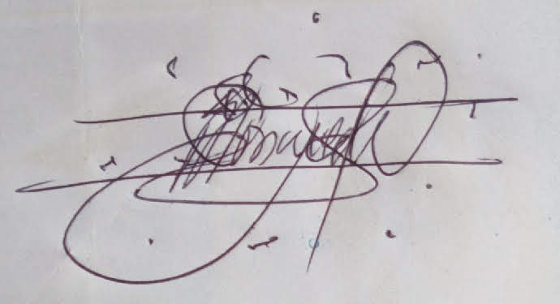
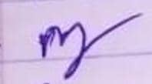

___________________________ ___________________________
Chief Executive Officer Secretary

